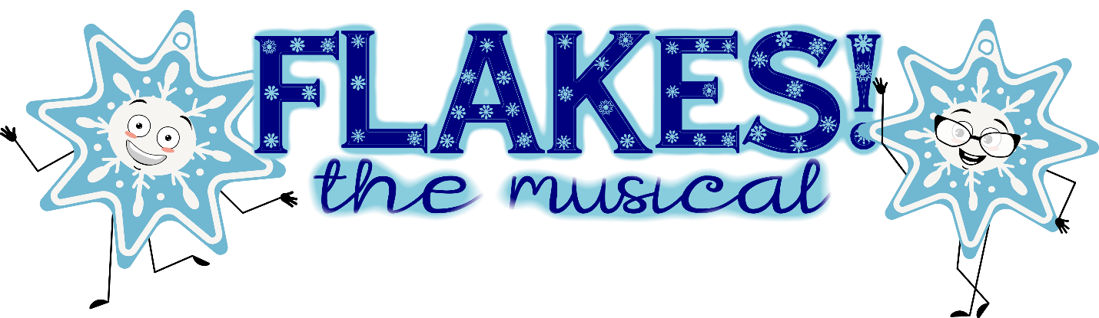Get ready to embark on a snowy adventure like no other with "Flakes! The Musical. A Blizzard of FUN!”
ABOUT: As the North wind starts to blow and temperatures plummet to ten below zero, a jazzy and finger-snappin' ensemble of snowflakes takes center stage. These cool and unique snowflakes are about to prove that no two flakes are alike, and that we are all special in our own way.
But wait, here comes the snowplow! Join in the excitement as the Flakes and their whimsical friends, the Snirts, come to the rescue the Littlest Snowflake. Together, they embark on a magical journey that celebrates the joy of winter and the beauty of individuality.
Kids will learn choreography, staging, acting and music. There are many speaking roles for all! Class size is limited to 25 students, so register today!
For ages 5-9
Directed by Katie and Madi Gankosky
Rehearsal dates: 6-7pm
Mondays: September 14, 21, 28 October 12, Nov. 2, Dec. 14*
Thursdays: September 3, 10, 17, 24 October 1, 8, 15, 22, 29 Nov. 5, 12 Dec. 3, 10
*Tuesday Dec. 15th, Wed. Dec 16th and Thursday Dec. 17th are mandatory rehearsals 6:00-7:30pm
*Show dates: Dec. 18th (at 7:00pm) and Dec. 19th (at 1:30pm)
*Mandatory dates in yellow
Although not encouraged, we ask that you limit conflicts to 3 rehearsals. Please indicate on your registration any conflicts you have.
Registration cost: $125
Register at www.perrysburgmusicaltheatre.org
Note: Rehearsals will be light in November due to PMT’s production of Les Misérables and Thanksgiving week.

